CLINIPICS
Intra–arterial line: a nightmare!!

Perundurai Chinnaswamy Vijayakumar
Director Academics, Chief Anesthesiologist and Intensivist at Sooriya Hospital, Saligramam,Chennai, India;
E-mail: drpcv_2006@yahoo.co.in

A patient had invasive hemodynamic monitoring for Whipple’s procedure. Upper limb arterial cannulation failed due to vasospastic arteries. So her right femoral artery was cannulated and used for 48 h postop to manage the hypotension with continuous thoracic epidural analgesia. Phenylephrine was used in very low dose for a day to prevent hypotension! She was on LMWH as DVT prophylaxis. On 7th day she complained of numbness/immobility and pain in her right lower limb! No pulses could be palpated down the line of femoral artery! She was diagnosed to have acute limb ischemia with septic shock. The thrombus propagated to involve the iliac vessels.
Emergency thrombectomy was done, which saved her limb.
It is suggested that every center has set protocols to avoid such adverse event. Frequent ultrasound examination of the cannulated blood vessels will us to make quick decisions.

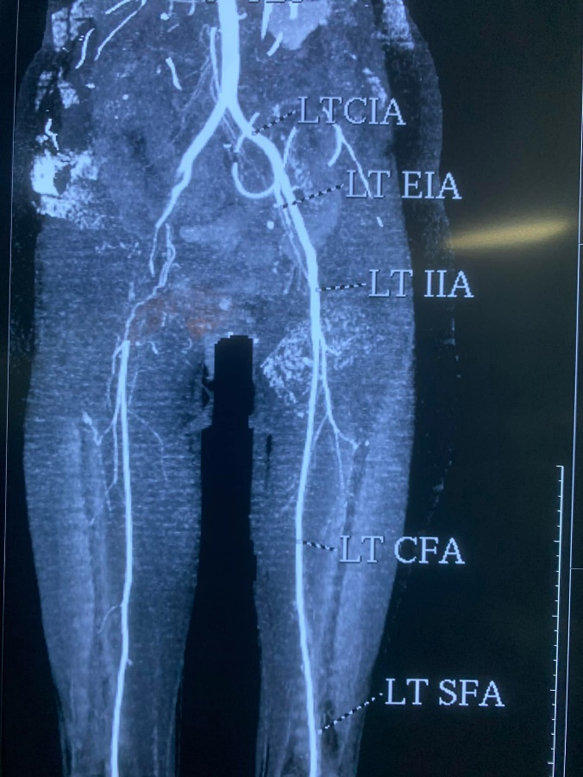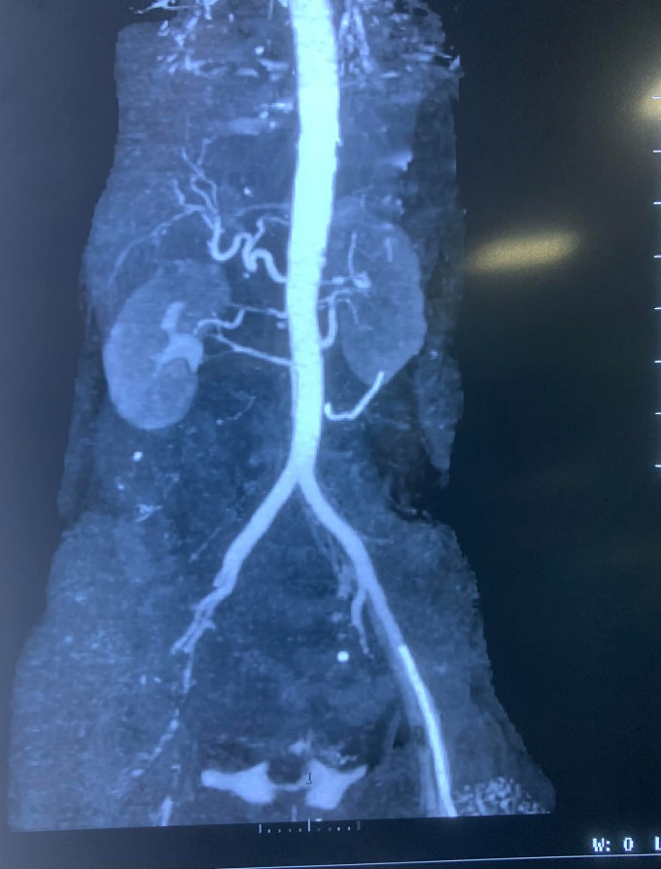
Figures showing almost complete blockage of the right femoral artery and the iliac arteries due to thrombus formation.

